Prototype

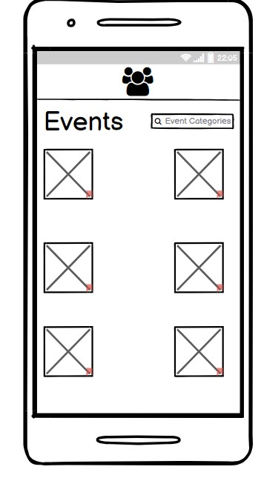

One of my unique functions for my prototype is when you click on the listed events, it takes you to the page below, giving full information about the event selected.

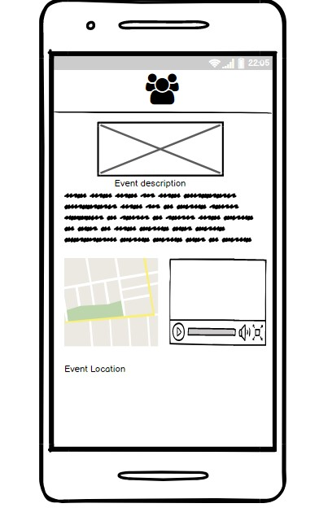

As shown above after clicking a selected event, it gives you a promotional video on the event, the location and also the description.

Another unique page that I decided to add into this event app is the forum page, where students can read featured topics and also discuss in the forum.

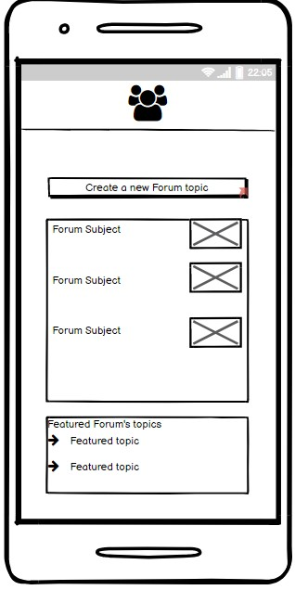

After clicking to create a new topic it will then lead the user to this

page

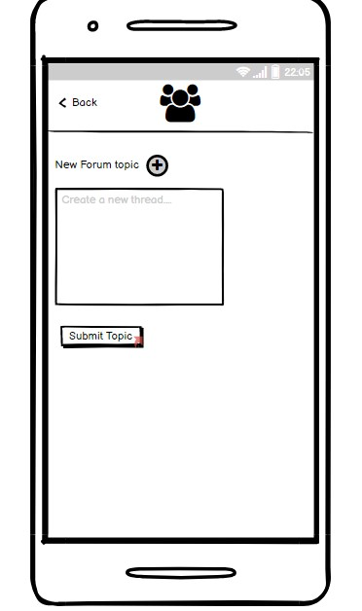

Usability Questions

What parts of the web/mobile app did you like the most? Why?

What parts of the web/mobile app did you use the least? Why?

What did you think of the interface?

What do you think about the way features and information were presented?

Why will you keep using this web/mobile app?

Prototype Link

https://balsamiq.cloud/s97nqsb/phw7upb